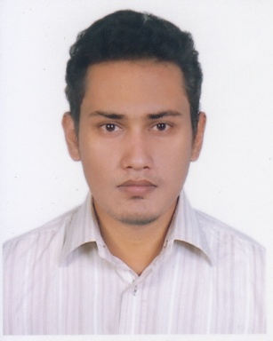
RESUME OF
MD. ABDUR RAFI IBNE MAHMOOD

Objective:
To pursue an achievement oriented and challenging career in a reputable and dynamic organization to utilize my skill and experience that needs and appreciates a result oriented professional and also provide me the opportunity to explore my full potential. Utilize my professional as well as interpersonal skills for making a mentionable contribution to the growth of the organization and also the society.

Bachelor of Science
Department of Computer Science and Engineering
Jahangirnagar University

Ongoing(Tentative date of completion: December 2014)
Current CGPA: 3.60

Academic Qualification HSC (Science)
Notre Dame College
Securing GPA 5 in English, Physics, Chemistry, Math and Computer Science.
SSC (Science)
Saint Joseph Higher Secondary School
Securing GPA 5 in all subject.

Secured Version Control for Course Syllabus Management System
Thesis Under the supervision of
Dr. Mohammad Zahidur Rahman.
Professor, Department of CSE, Jahangirnagar University

Reform Based Version Management System for XML Data ,
Publication International Journal of Computer and Information Technology (ISSN: 2279 – 0764)
Volume 03 – Issue 06, page 1299-1304, November 2014.

Programming language:
# Comprehensive knowledge on Java.
# Good knowledge and coding experience of C and C++.
# Have some knowledge of C#, python, lisp, prolog

Web Development:
Skills # Have good knowledge of HTML, XML, JSP, servlet.
# Have some knowledge of PHP, JavaScript, Bootstrap.

Database:
# Have good knowledge of MySQL.
# Have some experience with Oracle.

Others:
# Have worked on various academic projects with MATLAB.

# Diligent
# Quick learner
# Multi tasking
Professional # Proficient in Presentation
Skills # Can be a good leader.
# Can control responsibilities and committed to own work

# Have been involved in all the programming contest arrangement and events in Department of CSE.
Experience # Was the instructor for competitive programming in the respected Department (2011-2012)
# Has worked on various projects as course requirements.
# Was teacher’s assistant from 2013-14.
# Teacher at “Room to Read” (an award-winning non-profit organization for improving literacy and gender equality in education in the developing world.) from 2012-13.

# Founder of “SHOPNO” an unregistered non- profit organization for street children which functioned from 2008-2012. Hope to resume it soon.
Extra Curricular # Was Captain of the cricket team of my department for straight 2 years.
Activities # Played in the department football, basketball, handball team.
# For last 5 years did private tuition. I have more than 15 students.

# Professional Java training form IAC, BUET , Dhaka, Bangladesh.
Training # National Android App training. (Arranged by Ministry of ICT.)

Language Read Write Speak
Bengali Excellent Excellent Excellent
Language Skill English Excellent Excellent Excellent
Japanese Little Little Moderate

# Interested in Machine Learning and Data mining related research and software for autistic children.
# Interested in programming. Want to learn the programming and the development more
Interest # Interested in “Data Science” and “Algorithms”.
# Software development and Server side development.
# Interested in Robotics also. (As I want to learn robotics in the future.)

----------------------------------------------------
Signature
Date: December 16th, 2014.

