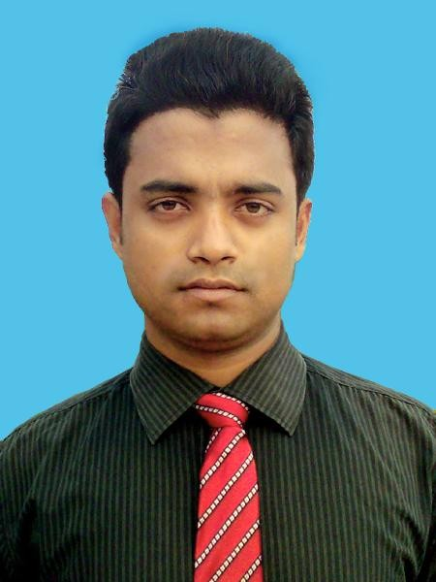

S.M. NAZMUS SALEHIN

Make something enlightening to human beings…..
Have been involved with in ICT terminology (programming, technology and system analysis) therefore trying to derive out the core enrollments and concepts behind it to optimize the humanly adaptation of the technological evolution. Basically I been trying to be an analyst (programming, system and technology) to deliver high optimality of technological evolution of Corporate.

Technical Skill
I would like to do believe my professional ideology with solid confidence, just able to learn and adapt any kind of syntaxes and technologies as per the necessity of corporate and consumer. I have working expertise of DotNet technology with MS SQL 2000/2005/2008R2 and various syntaxes: C#, ASP, Javascript and CSS. I also have working availability of another kind of syntaxes: C, C++, JAVA, HTML , Oracle, HTML5 and Analysis & Design (OO) using DFD (Data Flow Diagram).

Research Scope:

Quantum Computing Technology
- Statistical Data Processing (SDP)
- Artificial Intelligence (AI) and Knowledge Management.
- RSA Cryptography and Genetic Algorithm
Career Summary
At 19 December, 2009 I did an initiation of my career life as junior analyst (Algorithm and DFD) with key job responsibility: Object Oriented Analysis and Design (OOAD). But in there I had to confront some problem and being concluded the necessity of system development experience or software coding expertise. Therefore I had decided to switch in order to enrich my introspection; involved to contribute with UGC-IT as an ERP developer to ensure their (Uttara Group of Companies) in-house IT solutions. Now I been working with in-house development team of Janata Bank Limited to develop and deploy their IT infrastructure and core banking solution.
.

Total Year of Experience: 5.5 years / [Five and half years]

Job Details:
1. Assistant Programmer (July 08,2012 --- Continuing)
Janata Bank Limited, Head Office (Janata Bhaban-20th floor), In House Development Cell. 110 Motijheel C/A, Dhaka http://www.janatabank-bd.com
Job Responsibility: Develop and Deploy Banking Software and Database Servers
Working Languages and Tools: DotNET Technology (C#.NET), Janata Bank Custom Tools, MS SQL Server 2000/2005/2008r2.
Successful Modules: Accounts, Control and Administration [Centralized Control, Distributed Counter Administration], EFMS [Employees’ Fund Management System]
2. Executive-IT (Jun 01, 2011 –--- July 04, 2012)
Uttara Group of Companies, Head Office (Uttara Trade Centre), 102 Shahid Taj Uddin Ahmed Sarani, Tejgaon, Dhaka., http://www.uml-bd.net
Job Responsibility: ERP Developer (Live Project)
Working Languages: DotNET Technology (C#.NET) and MS SQL 2005 Enterprise. Successful Modules: HRMS [Human Resource Management System], Commercial [Import] , Production, Service [Web based].
- Junior Analyst (December 19, 2009 –--- May 29, 2011) Supernova Software Ltd. Mirpur-6, Dhaka.
Job Responsibility: Analyst and Designer (OO)
Working Tools: DFD (Data Flow Diagram) and Algorithm
Successful Modules: Student Register, Expert Shopper [Inventory], Adaptive Billing Engine

Professional Courses
  - Diploma on Advanced Java, Duration: 12 months, Computer Science & Engineering Department, BUET, Dhaka, Bangladesh. Course Status: Continuing

Thesis Works
  - Thesis on “The role of artificial programmers (APs), perspective digital era.”
  - Thesis on “Evaluation and Performance analysis of RAS algorithm as security policy.”

Certifications and Memberships
  - Course on English Language (Four skills), Mentor Language Institute, Kushtia.
  - Membership of Lalon Academy, Kushtia.
  - Associate Membership of Bangladesh Computer Council (BCS).

Academic Background

Name of the Examination | Board/University | Subject/Group | Result | Year of Exam. | (%)
MS in ICE | Islamic University, Kushtia. | Information & communication Engineering(ICE) | 3.28 (CGPA) | 2010

BSc in ICE | Islamic University, Kushtia. | Information & communication Engineering(ICE) | 2nd Class | 2008(Held in 2009) | 58
H.S.C | Jessore | Science | 3.40(GPA) | 2004 | 60-70
S.S.C | Dhaka Technical Board | Computer Application | 4.18(GPA) | 2002 | 60-80
Personal Information
Name | S.M. Nazmus Salehin
Father’s Name | Md. Azizur Rahman
Mother’s Name | Most. Saleha Rahman
Mailing Address | 18/1/Ga (2nd Floor-Right), K.M. Das Lane, Tikatoli, Motijheel CA, Dhaka
Permanent Address | C/O: MD. Azizur Rahman, Village: Mohonnogor Post Office: Gobra Chandpur Police Station: Kumarkhali District: Kushtia Cell: 0088-01714-674203
Home District | Kushtia
Date of Birth | 1st January, 1988
Nationality | Bangladeshi (by birth)
Blood Group | AB(+ve)
Sex | Male
Marital status | Married
National ID card No | 5017117660821
Religion | Islam(Sunni)
Email | smrubel_ice@yahoo.com
References

Dr. M. Mahbubur Rahman.

Professor, Department of Information and Communication Engineering (ICE). Islamic University (IU), Kushtia-7003, Bangladesh
Mobile: 0088-01711-007192, Tel: +88-01727-300-119, Fax: +88-071-62399
Email: drmahbub_07@yahoo.com, Reference Type: Academic

Md. Matiul Islam

Sr. DGM (IT), Uttara Group of Companies, Uttara Trade Centre, 102 Shahid Taj Uddin Ahmed Sarani, Tejgaon, Dhaka.Cell: 0088-01552405567, Tel: +88-02-8144330-Ext 506, Email: matiul@yahoo.com, Reference Type: Professional
Md. Abul Kalam Azad
DGM, Janata Bank Limited,IT Department (System), Head office, Motijheel C/A, Dhaka. Cell:+88-01552354677 , Telephone:+88-02-9553336,
Email:dgmitdsystem@janatabank-bd.com, Reference Type: Professional

-----------------------------

Signature
(S.M. NAZMUS SALEHIN)

